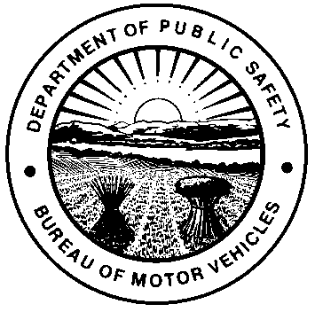 |  | OHIO DEPARTMENT OF PUBLIC SAFETY  BUREAU OF MOTOR VEHICLES  FIFTY HOUR AFFIDAVIT
PLEASE PRINT
NAME OF TEMPORARY PERMIT HOLDER |  |  |  |  | TEMPORARY INSTRUCTION PERMIT I.D. #
ADDRESS |  |  |  |  | CITY |  |  | STATE |  |  | ZIP CODE
NAME OF ELIGIBLE ADULT* |  |  |  | DRIVER LICENSE / I.D. CARD # |  |  |  | RELATIONSHIP TO TEMPORARY PERMIT HOLDER
ADDRESS |  |  |  |  | CITY |  |  | STATE |  |  | ZIP CODE
E-MAIL ADDRESS OR TELEPHONE #

The eligible adult identified above personally appeared before me and attested that the temporary permit holder has truthfully recorded in the Supervised Driving Log section the completion of at least fifty (50) hours of actual driving experience. This includes ten (10) hours of driving experience accumulated during nighttime hours, defined as the period commencing one-half hour after sunset and concluding one-half hour before the following sunrise. An eligible adult is either the parent, guardian, or custodian of the applicant or a person over the age of twenty-one who acts in loco parentis of the applicant.
*If the temporary permit holder identified above is applying for a limited term Non-Renewable and Non-Transferrable Driver License, then the eligible adult who supervises the permit holder’s driving experience must have a valid Ohio Driver License and be the same adult who completes this attestation.
SIGNATURE OF ELIGIBLE ADULT
X
Sworn to and subscribed in my presence this day of , 20 in County,
State of .
(Notary Seal)
Signature of Notary Public X My commission expires
NOTICE: Falsifying an affidavit is punishable by fine and/or imprisonment (Ohio Revised Code Section 2921.21 and 4507.21).
SUPERVISED DRIVING LOG
DATE | Supervising Licensed  Driver Name |  | Supervising Adult  Ohio Driver License # |  |  | Start & End Time  Include AM or PM |  |  | Total Day Time |  |  |  | Total Night Time
DATE |  |  |  |  |  | Start | End |  | Hours | Minutes |  | Hours |  |  | Minutes
Minimum of 50 hours of required supervised driving. 40 hours of day time driving and 10 hours of night time.
(Continue on the back if needed)
SUPERVISED DRIVING LOG (continued)
DATE | Supervising Licensed  Driver Name |  | Supervising Adult  Ohio Driver License # |  |  | Start & End Time  Include AM or PM |  |  | Total Day Time |  |  |  | Total Night Time
DATE |  |  |  |  |  | Start | End |  | Hours | Minutes |  | Hours |  |  | Minutes
Minimum of 50 hours of required supervised driving. 40 hours of day time driving and 10 hours of night time.

